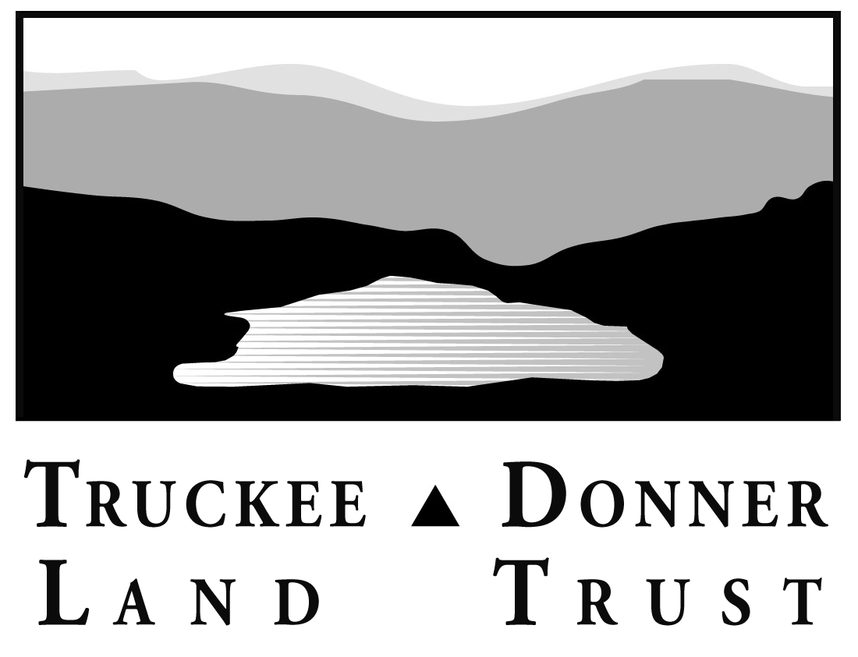
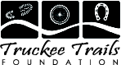

Buck for Open Space & Trails
Program Description
The Program
The Buck for Open Space & Trails (BOS&T) program is a partnership of community-minded local businesses who provide a way for their customers to support open space and trails in Truckee by adding a mere $1 to their bill. The BOS&T does not cost you, the business owner, anything. The folks who donate to the program are your customers. The funds benefit the Truckee Trails Foundation and the Truckee Donner Land Trust.

The revenue is generated through a $1 contribution added as a separate line item to the customer’s bill at checkout. Participating restaurants add the fee, but provide a mechanism for the customer to easily opt out. Retail establishments and hotels ask the customer at the time of payment if they’d like to add a Buck for Open Space & Trails to their total.

Similar programs have been very successful in Jackson Hole and Crested Butte. Crested Butte has generated over $800,000 over the course of the last 6 years, preserving critical natural areas in the process.

The program can also benefit your business. A number of our supporters have indicated that they would prefer to patronize BOS&T participants when possible. This fits with the experience of Jackson Hole and Crested Butte businesses who have found that very few customers opt out and that many were interested in protecting local open space, but had never taken the time to figure out how to get involved.

Use of Funds
Funds are split 50/50 between the Land Trust and TTF to protect our open space and expand our trails system in the Truckee region. As you know, our natural areas, scenic vistas, and great hiking, biking, skiing and climbing are what keep locals here and visitors coming back for more. Preserving open space and a viable trail system in our community is investing in our region’s economic future.

Participants
Dragonfly, Cottonwood, Pacific Crest, Pianeta’s, West End Bistro and Catering, Best Western Truckee Tahoe Inn, Inn at Truckee, Donner Truckee Veterinary Hospital Jackass Ridge, Cabona’s, Alpine Mounting/TahoePoster.com, and JoAnne’s Stained Glass are currently participating.

Benefits
The benefits of this program are:
- Promotion of your commitment to our community in your place of business through attractive program materials.
- Directly assisting the Land Trust and the Trails Foundation. These funds will help us protect landmarks like Schallenberger Ridge, purchase popular recreational areas like Negro Canyon and the Truckee River Corridor, and expand the Town’s trail and bikeways system.
- Recognition as a BOS&T participant in Land Trust & TTF publications, press coverage, and periodic advertising.

How it Works

The Land Trust and TTF have developed eye-catching marketing materials with a brief program description. We also provide a window sticker and fact sheets. The materials help demonstrate your commitment to preserving open space and trails.

All of the participating businesses have figured out efficient and uncomplicated ways to present and account for these fees, which they’re happy to share. For example at Dragonfly, the bill says to circle the charge if you’d like to remove it, so the customer can easily and without embarrassment opt out of the program.

The monthly total is simple to calculate. Total all sales and account for all taxes, and whatever is left goes to the Land Trust & TTF. It is not necessary to figure out each bill. Businesses send the income collected to the Land Trust monthly. The Land Trust forwards 50% to TTF.

From a training perspective, you need to inform your staff about the program, how to ask customers to participate and how to add or subtract the charge. The Land Trust and TTF should brief your employees on our work and the benefits this program provides to our community’s quality of life, so that they can personalize responses based on what they value about our work. And both organizations are happy to answer customer questions or provide additional information to you or your staff.

We hope you will join us!
You know the urgency of our work as well as we do. TTF and the Land Trust are in a race against the unrelenting pace of growth in our region, which is spilling over into some of our most treasured natural areas and recreational lands. But with the support of our neighbors and partners, we can protect what we love, forever, before it’s too late. Your partnership can help keep the Truckee Donner region a great place to live or to visit.

