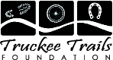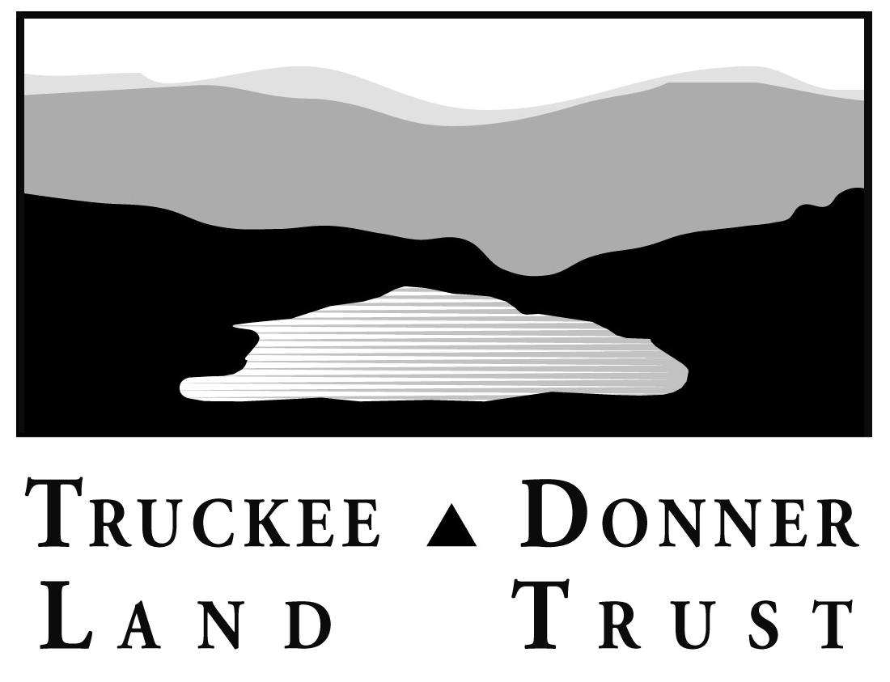

Buck for Open Space & Trails

Questions & Answers

***What is the “Buck for Open Space” program?***

It’s a partnership of community-minded local businesses that provide a way for their customers to support open space and trials in Truckee by adding a $1 to their bill at checkout.

***How will the funds be used?***

Funds are split between the Land Trust and the Truckee Trails Foundation (TTF) to protect our open space and expand our trails system in the Truckee region.

***What is the Truckee Donner Land Trust?***  
Founded in 1990, the Truckee Donner Land Trust is a non-profit organization that protects the wild and natural places - rivers and lakes, mountains and meadows - that define our region. We work with willing sellers to craft win-win solutions that ensure continued recreational access and protects our lands for future generations. Our work protects what we cherish about living or visiting here.

We are determined to protect our area’s historic character and scenic beauty by protecting another 30,000 acres. And you can count on us to get it done. We’ve already protected over 7,000 acres. We’re in a race against the unrelenting pace of growth in our region, but with the support of our neighbors and partners, we can protect what we love, forever, before it’s too late.

***What is the Truckee Trails Foundation?***

Founded in 2002 upon the completion of Truckee’s landmark *Trails and Bikeways Master Plan*, the Truckee Trails Foundation’s goal is deceptively simple: To provide the Truckee area with a network of trails and bike paths for fun, adventure, and alternative transportation.

To make this happen, we’re devoted to partnering with anyone, anytime, and anywhere in Truckee to make trails and bikeways happen. To date, TTF has worked with partners such as:

* Truckee Donner Land Trust (Co-hosted a two day Trail Building Seminar);
* The Town of Truckee (Adding between 35-45 miles of biking routes in Summer 2005 along with the release of Truckee’s first bike map);
* The Our Truckee River Legacy Foundation and Truckee Rotary Club (TTF is part of the project management team for Rotary’s Truckee River Legacy Trail);
* East West Partners (Researching and designing a Downtown Trail link that will connect up to eight Truckee neighborhoods to Downtown);
* US Forest Service (Developing an Olympic Heights trail to Downtown).

Working with these great partners helps your ”Buck” go farther. In 2004, TTF was honored as Truckee’s Non-Profit of the Year.

***Why should I contribute?***

Truckee’s natural areas, scenic vistas, and great hiking, biking, skiing and climbing are what keep locals here and visitors coming back for more. But Truckee is booming and the wild open spaces we cherish are disappearing at an alarming rate.

This is your chance to help. Your Buck will directly assist the Land Trust and the Trails Foundation in protecting natural areas and expanding trails in the Truckee Donner region. These funds help us protect important landmarks like Schallenberger Ridge, purchase popular recreational areas like Negro Canyon and the Truckee River Canyon downstream, and create more options for you and your family to hike and bike along the Truckee River, overlooking Donner Lake, and to many of our area’s other attractions.

***How else can I help?***

Support other businesses with the Buck for Open Space & Trails sticker in their window. Best Western Truckee Tahoe Inn, Inn at Truckee, Cottonwood, Dragonfly, Pacific Crest, Pianeta’s, West End Bistro and Catering, Jackass Ridge, Cabona’s, Alpine Mounting/TahoePoster.com, Donner Truckee Veterinary Hospital, and JoAnne’s Stained Glass all participate. Join the Land Trust or the Trails Foundation. Check out our website and tell a friend about us. Get a group together and come out for a day building trail.

***How can I get more information?***

Call or email. Or stop by. The Land Trust office is in the Old Tonini House at 10069 West River Street (two doors to the east of Earthly Delights).

Truckee Donner Land Trust Truckee Trails Foundation

PO Box 8816 PO Box 1751

Truckee, CA 96162 Truckee, CA 96160

[www.tdlandtrust.org](http://www.tdlandtrust.org) [www.Truckeetrails.org](http://www.Truckeetrails.org)

[info@tdlandtrust.org](mailto:info@tdlandtrust.org) [info@truckeetrails.org](mailto:info@truckeetrails.org)

(530) 582-4711 (530) 587-8214

**Thank you very much for your support!**